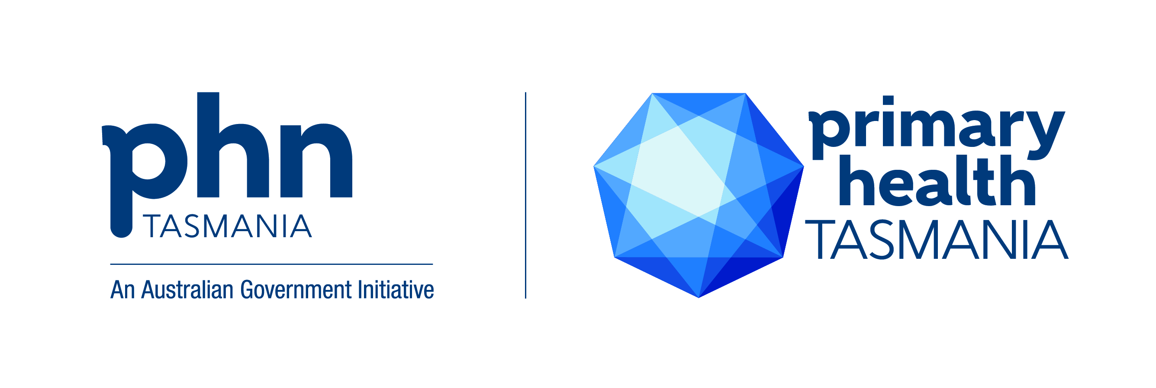
Primary Health Tasmania

Who are we?
Primary Health Tasmania (Tasmania PHN) is a non-government, not-for-profit organisation working to connect care and keep Tasmanians well and out of hospital. We are one of 31 similar organisations under the Australian Government’s Primary Health Networks (PHNs) Program.
We have strong working relationships with a broad range of private, public and community sector organisations across primary, acute, aged and social care. This puts us in good stead in our push for a coordinated, primary care-focused health system delivering the right care in the right place at the right time by the right people.

What are we doing?
The Government has set the following objectives for PHNs nationally:
- increasing the efficiency and effectiveness of medical services for patients, particularly those at risk of poor health outcomes; and
- improving coordination of care to ensure patients receive the right care in the right place at the right time.

How are we doing it?
We engage at the community level to identify local health needs and work with health system partners and providers on innovative solutions to address service gaps, including through commissioning services.
We support general practice – as the cornerstone of the health care system – and other community-based providers to deliver the best possible care for Tasmanians.
We are driving a collaborative approach to ensure people moving through all parts of the health system receive streamlined care.
Our clinical and community advisory councils help ensure clinical leadership and community perspectives feature strongly in our governance and inform our activities.

Our priorities
Our activities are based on national priorities set by the Australian Government as well as the identified needs of local communities and priority population groups.
They focus on service delivery, provider support and system improvement in the areas of:

- Aboriginal health
- after-hours care
- aged care
- alcohol and other drugs
- cancer screening
- chronic condition management
- connecting care
- digital health
- disease prevention
- emergency management
- immunisation
- intellectual disability (enhancing primary care)
- mental health
- palliative care
- potentially preventable hospitalisations
- primary care workforce support
- rural primary health
- suicide prevention.

Commissioning services
Commissioning is the process of working with communities and providers to identify health priorities; designing services to address those priorities; then procuring and implementing these services in partnership with providers to ensure they meet required outcomes. Commissioning is one of the roles the Australian Government has given all PHNs.
Our commissioned services are detailed in Our Services Portal: services.primaryhealthtas.com.au

More information
For more information about any aspect of our work, email us at info@primaryhealthtas.com.au or call us on 1300 653 169.
www.primaryhealthtas.com.au
Primary Health Tasmania Limited
ABN 47 082 572 629

February 2023

