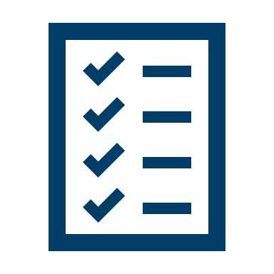
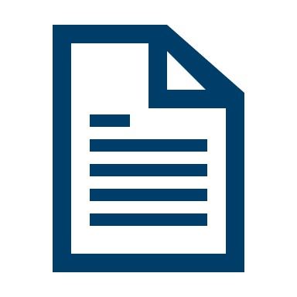
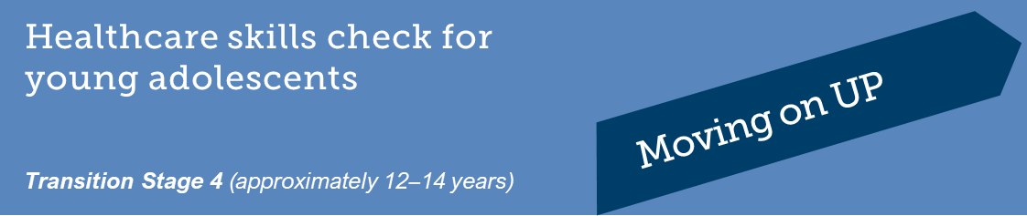
This form is to help identify the knowledge and skills you already have and what you need to work on.
This will help you manage your health as you get older and become more independent.

Complete the form and then discuss it with your doctor so you can both plan your care goals for the coming year. Your doctor may ask you to complete this form once a year to see how you feel you are going.

Ask your doctor for a copy so you can review it at home.

Name
Date of Birth |  |  | Date

Healthcare Skill Area | Yes | Mostly | Not yet | I’m not sure

Understanding my condition
I know the names of my healthcare team and what each person does.
I can explain my medical condition in plain terms.
I can explain my care plan in plain terms.
I know the names of my medications and what they are for.
I know what equipment I need for treatment and what it is used for.

My involvement with my healthcare team
I know who to ask if I have a question and I am comfortable asking.
I have a regular family doctor.
Before an appointment, I think about questions to ask.
I know I can have part of my appointment without my family/caregiver present.

My healthcare plan

I remember to take my medication or treatment with the help of my family/caregiver.

I know how to organise my equipment (if I use equipment).

Managing my condition
I know when my symptoms are serious, who to tell, and what I need to do to treat the symptoms.
I can describe changes in my health to my family/caregiver and healthcare team.
I know what to do when I become unwell.
I know when I need urgent medical help.
I know how to manage any allergies I have.
I have important phone numbers with me every day to use in an emergency.

My everyday health and lifestyle
I can discuss issues like stress, bullying, mental health, girlfriends and boyfriends, physical changes, alcohol, drugs, and smoking with my family/caregiver or healthcare team.
I eat well to help me stay happy and strong.
I exercise regularly.

Getting support when I need it
I have other people in my life that I can talk to about my condition, for example friends, family, teachers, sports coaches.
I know who to contact if I need help with my medical condition.
I know about resources that offer support for young people in my situation.

