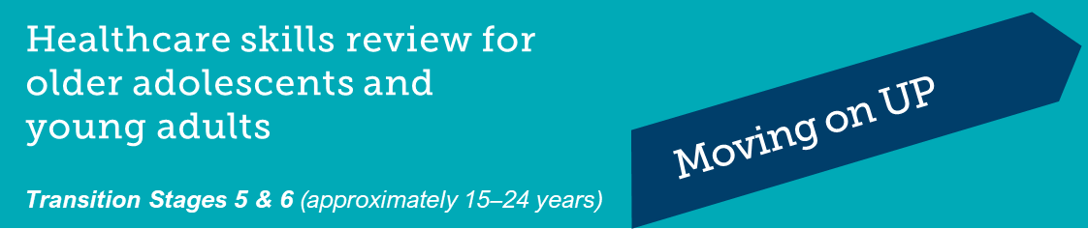
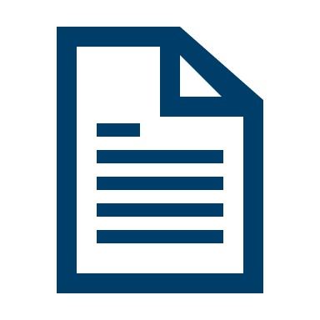
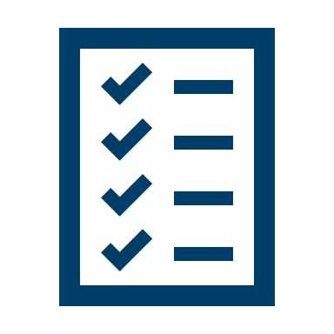
This form is to help identify the knowledge and skills you already have and what you need to work on.
This will help you manage your health as you get older and become more independent.

Complete the form and then discuss it with your doctor so you can both plan your care goals for the coming year.

Ask your doctor for a copy so you can review it at home.

Name
Date of Birth |  |  | Date

Healthcare Skill Area | Yes | Mostly | Not yet | I’m not sure

Understanding my condition
I can confidently describe my medical condition.
I understand and can explain my care plan.
I know the names of my medications and what they are for, including how much and when to take them.
I know the side effects and restrictions of the medications I take.
I know what equipment I need for treatment and how to use it.
I know what tests I have regularly and why I need to have them.
I know where to get more information about health topics.

My involvement with my healthcare team
I know who to ask if I have a question about my health and I am comfortable asking.
I have a regular family doctor.
I can make and reschedule my own appointments.
Before an appointment, I think about what questions to ask.
I arrive on time or a bit early for my appointments.
I have been to appointments by myself, without my family/caregiver present.
In between appointments, I will phone or email my healthcare team if I need to.
I understand my rights to privacy and to make decisions about my health care.

My healthcare plan
I remember to take my medications or treatment.
I am responsible for getting my prescriptions and having them filled.
I know how to organise and reorder my equipment, if needed.
I keep copies of my care plans, test results, clinic and discharge letters.
I know how to organise payment for my appointments and treatments.

Managing my condition
I monitor and respond appropriately to my symptoms.
I can describe changes in my health to my family/caregiver and healthcare team.
I know what to do when I become unwell.
I know when I need urgent medical help.
I know how to manage any allergies I have.
I carry important health information with me every day, for example Medicare card, allergies, medications, emergency contact information, medical summary.

My everyday health and lifestyle
I eat well to help me stay happy and strong.
I exercise regularly.
I have talked with my healthcare team about:
- how my medical condition affects my mental health.
- how my medical condition affects my sexual and reproductive health.
- the effects of smoking, alcohol, and drugs on my health.

Getting support when I need it
I have other people in my life that I can talk to about my condition, for example friends, family, teachers, sports coaches.
I know who to contact if I need help with my medical condition.
I know who to contact if I need medical support after hours.
I know where and how to get information about peer support programs like camps, online or face-to-face groups for young people in my situation.
I know about organisations that offer support for young people in my situation.

Moving to new adult services
I have my own Medicare card.
I have my own Health Care Card.
I have a My Health Record or have talked to someone about whether I want this.
I know whether I have private health insurance.
If I have private health insurance, I know the name of my insurer and my member number.
I have been given information about the new services and I am comfortable with the choice.

