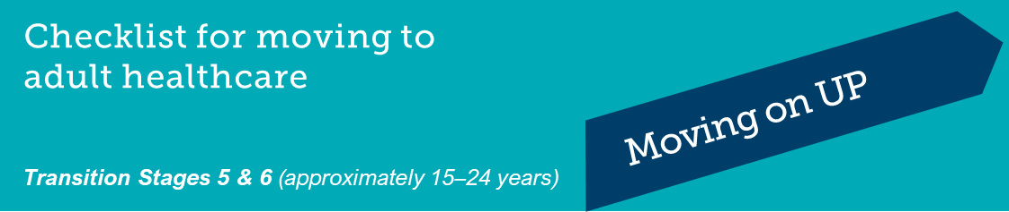

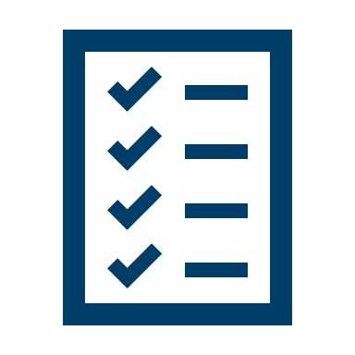
This checklist is to help track the skills, knowledge and processes involved in moving to adult healthcare.
It will help you keep track of what you need to know, do and take care of during this transition phase between your existing and your new healthcare services.

Complete the form as you go and discuss it with your doctors at each appointment. You can tick,
write the date or write NA (not applicable) if it doesn’t seem relevant to your situation.

Ask your doctor for a copy so you can review it at home.
Name
Date of Birth |  |  | Date

Healthcare Skill Area | Completed | Notes

Understanding my condition
I can confidently describe my medical condition.
I understand and can explain my care plan.
I know the names of my medications and what they are for, including how much and when to take them.
I know the side effects and restrictions of the medications I take.
I know the equipment I need for treatment and how to use it.
I know the symptoms I need to watch for, the regular tests I need and why, and how often I need them.

My involvement with my healthcare team
I have a regular family doctor.
I make and reschedule my own appointments.
I have attended appointments without my family/caregiver there.
In between appointments, I phone or email my healthcare team directly if I need to.

My healthcare plan

I am responsible for remembering to take my medications and treatment.

I am responsible to get my own prescriptions and have them filled.

I know how to order and organise my equipment and how to keep it in good working order.

I keep copies of my care plans, test results, clinic and discharge letters in hard copy, email or photo.

Managing my condition
I know what symptoms to watch for and how to respond to them.
I know what to do when I become unwell or need urgent medical help.
I carry important health information with me every day, for example Medicare card, allergies, medications, emergency contact information, medical summary.

My everyday health and lifestyle
I have talked with my healthcare team about:
- how my medical condition affects my mental health
- how my medical condition affects my sexual and reproductive health
- the effects of smoking, alcohol, and drugs on my health.
I know where to get more information if I need it.

Getting support when I need it
I have other people in my life that I can talk to about my condition, for example friends, family, teachers, sports coaches.
I know who to contact if I need help with my medical condition.
I know who to contact if I need medical support after hours.
I know where and how to get information about peer support programs like camps, online or face-to-face groups for young people in my situation.
I know about resources that offer support for young people in my situation.

Moving to new adult services
I have my own Medicare card.
I have my own Health Care Card.
I have a My Health Record or have talked to someone about whether I want this.
I know whether I have private health insurance.
If I have private health insurance, I know the name of my insurer and my member number.
I know who I can go to if I have questions or need help planning the move to adult healthcare.
I know what my care plan is and have discussed this with my healthcare team(s).
A detailed medical summary has been prepared for the new team, and I have a copy.
I know the names and roles and contact details of the people I’m seeing in the new services.
I know how to book and change appointments at my new services.
I know how to get to my new services.
I have visited the new healthcare services I am moving to.
I have met my new healthcare team.
I have attended my first appointment at my new healthcare service.

Non-medical areas of life
I know if I must declare my medical condition when applying for a driver’s licence.
I know if I’m eligible for financial support or concessions from Centrelink.
I have my own bank account.
I have a MyGov account.
I have applied for a tax file number.
I have enrolled to vote.
I have found out about special consideration for assessments and exams at school and university.
I have thought about how I will keep in touch with friends once school ends.

