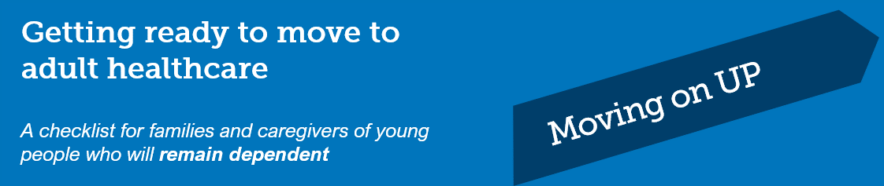

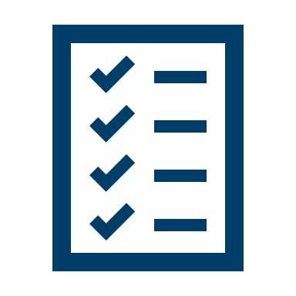
Use this checklist to identify the skills you have and the areas where you may need to increase your knowledge as your young person gets ready to move to adult healthcare.

Talk to your healthcare team about any gaps you’ve identified, and what you can do to be ready for your young person’s move to new services.

If your young person doesn’t have a GP, ask friends, family and health professionals for recommendations. The general practitioner becomes more important as the coordinator of care once your young person leaves the children’s health services.

Healthcare Topic | Yes | Not yet

General healthcare
My young person has a general practitioner (GP).
I understand my young person’s current health status and how to manage new symptoms.
I have talked with our GP about the impact of puberty on my young person’s condition, including how their condition might impact fertility.

The move to new services
I have talked to the healthcare team about any worries I have about moving to adult healthcare.
I have talked with members of our healthcare team about the services available as my young person enters adulthood.
I know who the key person is on the healthcare team who will help us with the move to adult healthcare.
I know what new services my young person will transfer to.
I understand which new service providers my young person will be transferred to.
I have asked the healthcare team who will be the key person who will assist me throughout the transition process.

Documents and plans needed for new services
I have prepared a ‘Top 5’ list for my young person to enable communication of my carer knowledge to the new health teams.
I have updated my young person’s health history, either with paper health history forms or in My Health Record.
I have worked with the healthcare team to develop a transition plan.
I have agreed to a date with the healthcare teams after which any hospitalisation will be to the adult hospital service.
I have a plan for disability supports for any inpatient stay in the adult hospital, visits to health professionals, management of chronic disease, and for healthy living at home.
I have asked for and received copies of relevant test results, clinic letters, and a detailed medical summary to give to the new care team.

How the new services work
I know how to order equipment and supplies in the adult healthcare system.
I know what ongoing monitoring and treatment will be like after leaving children’s health services.
I know how to make appointments in the new system.
I have met with members of the new team and know about parking, access, location of clinics, and staying overnight.

What support services are available in adult healthcare
I know about private health insurance and whether my young person will be covered.
I have contacted a representative of the National Disability Insurance Scheme (NDIS) and understand its role and relevance for my young person.
I know how to apply for NDIS benefits for my young person and how to seek a review.
If my young person is leaving school, I have investigated NDIS-supported post-school options.
I understand what may change in consent and guardianship arrangements as my young person becomes an adult.
I have checked with Centrelink to see if there are changes to concessions and financial support when my young person reaches 16 years old.

