Healthdirect Video Call pilot

Healthdirect Video Call pilot
Primary Health Tasmania is pleased to announce it will be participating in the Australian Government-funded Healthdirect Video Call telehealth platform pilot.
Participating in this pilot will allow use of the Video Call telehealth platform for free during the pilot period. The platform is easy to use for patients across a variety of devices (e.g PCs, mobiles and tablets), with no software installation required.
Information about the platform can be located at https://about.healthdirect.gov.au/video-call
Free access to this pilot will be available to approved participants in Tasmania until 30 September 2020. After this date participants can choose to continue using the platform under their own licence for a fee.
While the scope of this pilot is limited to general practice, Aboriginal Community Controlled Health Services and allied health organisations listed below in the first instance, other health organisations may apply to be included in scope (applications are subject to approval by the Australian Government Department of Health).
To register for the pilot, your practice can complete the application form below, and send to providersupport@primaryhealthtas.com.au. Each application will be assessed by Healthdirect and the outcome will be communicated to the applicant by Primary Health Tasmania.
Allied Health organisations in scope of pilot until 30 June 2020
Paediatrics and child health | Palliative medicine | Psychiatrists
Chiropractors | Diabetes educators | Exercise physiologists
Mental health workers | Midwives | Nurses
Aboriginal and Torres Strait Islander Health Practitioners and Health Worker | Nurse practitioners | Clinical psychologists
Psychologists | Occupational therapists | Social workers
Speech pathologists | Physiotherapists

Privacy and confidentiality
Organisations wishing to participate in the pilot must ensure they are familiar with the terms of use. Some specific points to note are:
- Primary Health Tasmania (Tasmania PHN) will be holder of the ‘organisation’ licence under which each participating practice will be set up (as depicted in figure 1). This is similar to the current licensing arrangement with the PenCS Clinical Audit Tool.
- Technically, Primary Health Tasmania administration users have the ability to see the virtual waiting areas of clinics set up under the Primary Health Tasmania organisation license (as shown in figure 2).
- To protect the confidentiality of patients and practices:
  - only two administration users from Primary Health Tasmania have access to the organisational account
  - they have each signed confidentiality agreements and organisational policies expressly forbidding access to virtual practice waiting areas within the platform
  - there is no technical ability for administration users to join or access a call-in progress.
- Primary Health Tasmania will not collect any data for any purpose under this pilot. Our role is strictly limited to providing participating practices with accounts and supporting access to the platform.

Figure 1. Healthdirect Video Call licence organisational structure
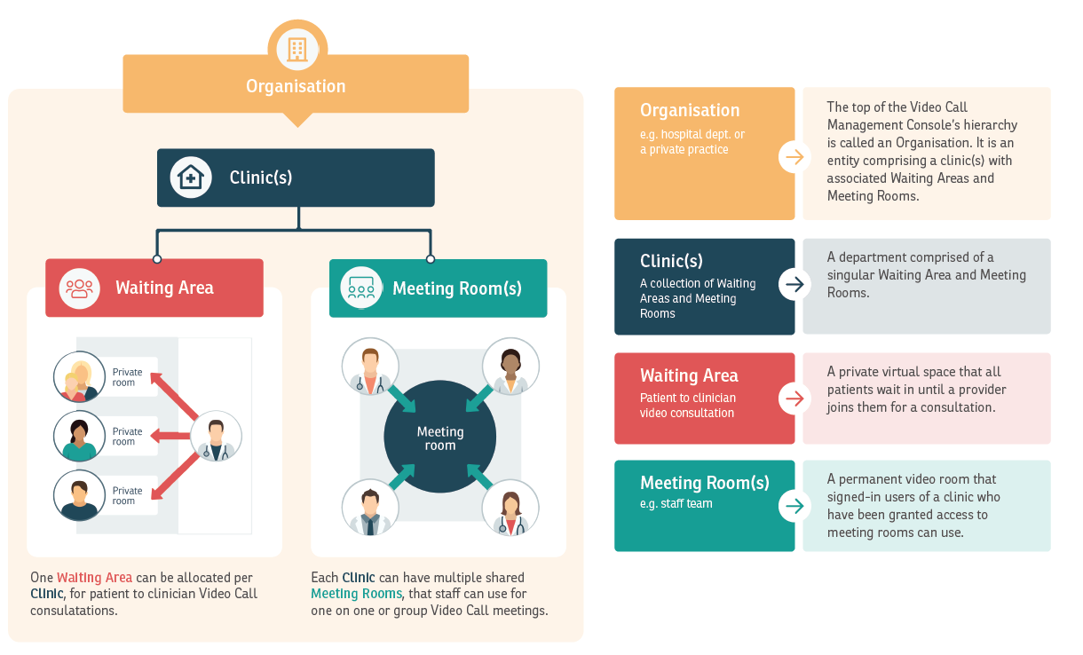

Figure 2. Healthdirect Video Call virtual waiting room view
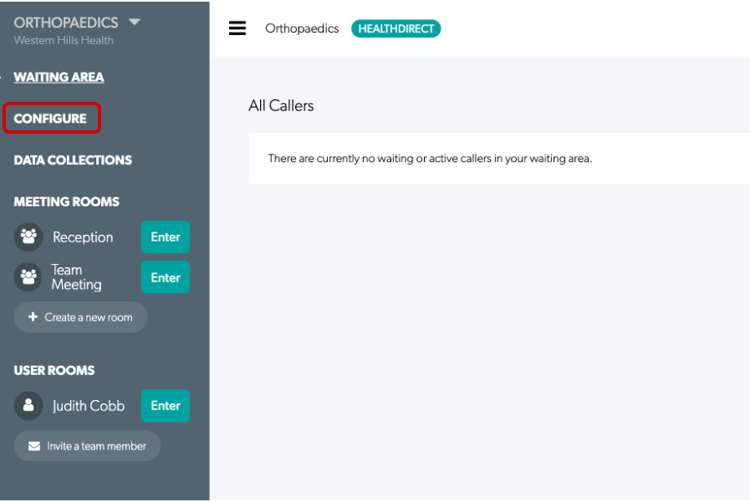
Primary Health Tasmania Limited ABN 47082 572 629
1300 653 169
providersupport@primaryhealthtas.com.au
www.primaryhealthtas.com.au

Business Case for a trial of the Video Call Service
Purpose: This coversheet has been developed to capture vital information to assist the Assistant Secretary in making an informed decision when considering the use of an operational licence for the Video Call Service pilot until 30 June 2020.
SECTION 1: Organisation / Program details
Please list the names of the non-government organisations entities /sites that are proposing to trial the Video Call Service:

Please provide the contact details of the officers that will be responsible for the implementation of the Video Call Service at each location (this information will be provided to the Healthdirect for administration purposes):

SECTION 2: Business case
Please describe the clinical / program purpose of using the Video Call Service in your organisation / Program:

Please provide a brief description of the benefits that will arise from the use of the Video Call Service pilot to the organisation / Program:

Please indicate which if any of the following groups will be targeted by the implementation of the Video Call Service:
☐ Rural and remote communities ☐ Indigenous population ☐ People aged 65 years old and over
☐ Chronic and complex conditions ☐ Other, please provide description________________________________
Do you agree to take part in a survey for evaluation purposes at the end of the trial period of the pilot? YES ☐ NO ☐
SECTION 3: Approvals
Assistant Secretary: Louise Riley, Primary Care, Dental and Palliative Care Branch
Date reviewed: Click here to enter a date.
Proposal Agreed: YES ☐ NO ☐

Assistant Secretary comments: Click here to enter text.

